Operational Concept Description (OCD)

LA Commons Upgrade of Website

Team 1

Name | Primary Role | Secondary Role
Hualong Zu | Project Manager | Prototyper
Qihua Wu | Life Cycle Planner | Operational Concept Engineer
Taizhi Li | Requirements Engineer | Life Cycle Planner
Huaiqi Wang | Prototyper | Requirements Engineer
Tianyi Luo | Feasibility Analyst | System Architect
Yueheng Li | System Architect | Operational Concept Engineer
Steiniger Herman | IIV & V | Quality Focal Point

12/06/2013

Version History
Date | Author | Version | Changes made | Rationale
9/25/13 | Yueheng Li | 1.0 | - Original for CSCI577; Tailored from ICSM OCD Template | - To fit CS577 course content
9/30/13 | Yueheng Li | 1.1 | - Add benefit chain  - Correct some misspelling | - Benefit chain is missing in last version  - Some words are misspelled
10/15/13 | Huaiqi Wang | 2.0 | - Tailored from ICSM OCD Template  - System Objectives, Constraints and Priorities  - Proposed New Operational Concept  - Organizational and Operational Implications | - To fit CS577 course content
10/19/13 | Huaiqi Wang | 2.1 | - Update benefits chain diagram, System Boundary and Environment Diagram  - Redo Business Flow (old and new)  - Update the entire contents in this document | - Modification according to ARB suggestions and rethinking
10/23/13 | Huaiqi Wang | 2.2 | - Update the program model and benefit chain | - According to teammates’ suggestions
12/01/13 | Huaiqi Wang | 3.0 | - Update the benefit chain, artifacts and ER diagram | - According to TA’s feedback
12/01/13 | Huaiqi Wang | 3.1 | - Correct some names to keep all names consistent in all documents | - According to professor’s feedback  - Update for final DC package

Table of Contents
Operational Concept Description (OCD) i
Version History ii
Table of Contents ii
Table of Tables iv
Table of Figures v
1. Introduction 1
1.1 Purpose of the OCD 1
1.2 Status of the OCD 1
2. Shared Vision 2
2.1 Overview of the system 2
2.2 Benefits Chain Diagram 3
2.3 System Boundary and Environment 4
3. System Transformation 5
3.1 Information on Current System 5
3.2 System Objectives, Constraints and Priorities 6
3.3 Proposed New Operational Concept 8
3.4 Organizational and Operational Implications 10

Table of Tables
Table 1: The Program Model 2
Table 2: The Artifacts of LA Commons Project 5
Table 3: Level of Service Goals 6
Table 4: Relation to Current System 7

Table of Figures
Figure 1:Result Chanin Diagram…………………………………………………………………………………………………3
Figure 2: System Boundary and Environment Diagram 4
Figure 3: Current Business Flow of LA Commons Website…………………………………………………………………..5
Figure 4: Element Relationship Diagram of upgraded LA Commons website …………………………………………….8
Figure 5: Business Workflow Diagram of LA Commons website ……………………………………………………………9

Introduction

Purpose of the OCD
This document provides, in detail, the shared visions and goals of the stakeholders of the LA Commons. The success-critical stakeholders of the project are the LA Commons Staff; Huaiqi Wang, Hualong Zu, Tianyi Luo, Qihua Wu, Taizhi Li, Yueheng Li, Steiniger Herman, as the project developer.

Status of the OCD
All sections are complete, ready to be included in the FC package.

Shared Vision

Overview of the system
Table 1: The Program Model
Assumptions
- More art programs will be held and need documentations
- Documents of art programs are already prepared by LA Commons staff
- Beneficiaries would like to see art programs’ information and the showcase of art works on the website
- Stakeholders | - Initiatives | - Value Propositions | - Beneficiaries
- Team members  - LA Commons | - Upgrade the website  - Provide tools training  - Market and promote LA Common's events  - Curate & Select text & images | - Increased the visibility of art projects  - Increased acknowledgement of neighborhood’s arts and culture  - More funds raised  - Increased popularity and reputation of LA Commons events  - Improved efficiency of maintaining the website | - Neighborhoods’ residents  - Community partners  - Artists  - Funders  - All people in LA and tourists
- Costs |  | - Benefits
- Website Hosting Costs  - Website Domain Costs  - Website Upgrade Costs  - Website Maintenance Costs  - Communication Costs of LA Commons staff  - WordPress template learning Costs  - Development Costs |  | Increased  - Number of website visitors  - Visitors’ time spent on the website  - Number of participations in LA Commons’ art programs  - Amount of funders’ donations  Decreased  - Search time of the documents  - Maintenance time for uploading documents  - Marketing time due to the sharing function.

Benefits Chain Diagram

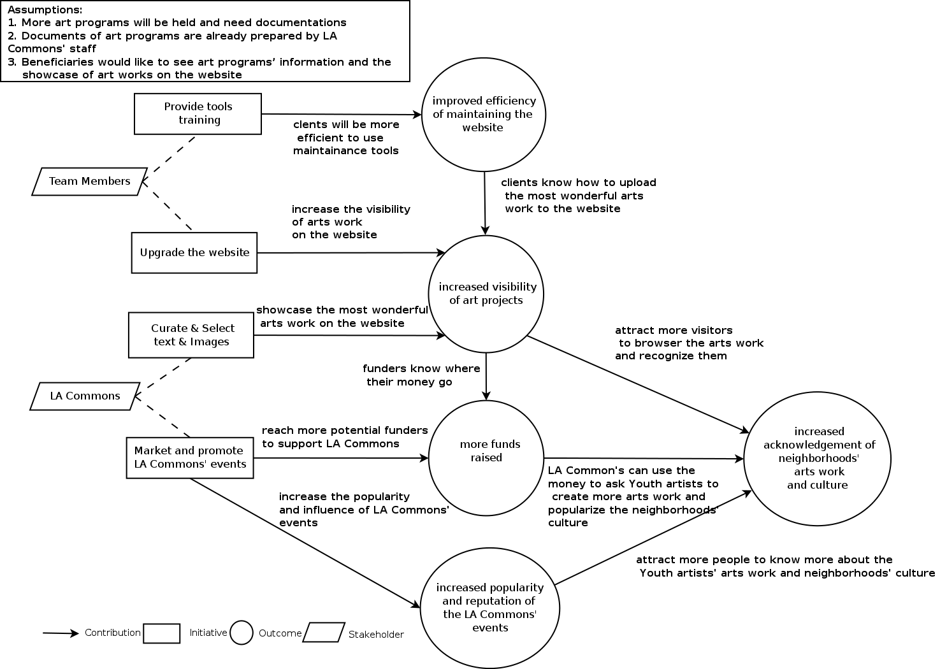
Figure 1: Result chain of LA Commons Update Website

System Boundary and Environment

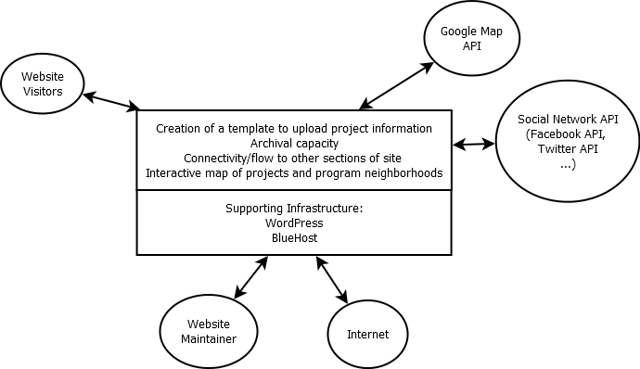

Figure 2: System Boundary and Environment Diagram of LA Commons Update of Website

System Transformation

Information on Current System

Infrastructure

Website is implemented using WordPress and is hosted on Blue Host.

Artifacts
- Images data for Photo Gallery: Pictures from past Community Arts Programs.
- Text data describing past Art Programs: Text data from LA Commons staff describing each past Community Art Program.
- Events: Information about past/upcoming events, such as date, position, etc.
- Blog Posts: Blogs Posts about news related to a particular neighborhood.
- LA Commons staff profile: Basic information about the staff working at LA Commons.

Current Business Workflow

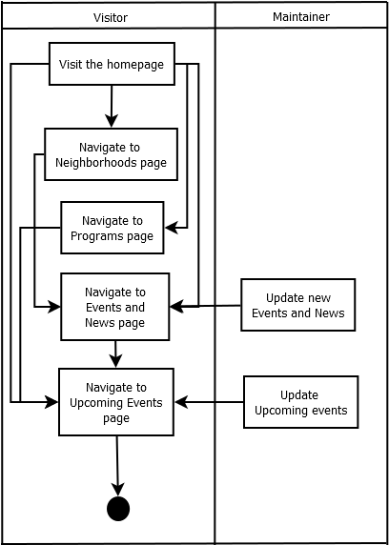
Figure 3: Current Business Flow of LA Commons Website

System Objectives, Constraints and Priorities

Capability Goals

Capability Goals | Priority Level
OC-1 Interactive Map: The map is used to integrate all neighborhoods in a map and is able to provide the users with a better navigation to browse all neighborhoods’ information on the website. | Could have
OC-2 Community Arts Project Page: The page is aimed to provide information about past Community Arts’ projects. In addition, in the Community Arts Page, add additional links to direct this page to the related Community Arts’ project pages to make them connected. | Must have
OC-3 Neighborhood Page Upgrade: Add a small gallery of community arts ’ arts work on the bottom-right page. Images from this small gallery direct users to the related neighborhood’s project page. | Must have
OC-4 Social Network Share Function: Visitors can share upcoming events, art works and information of posted projects on their social network page. | Must have
OC-5 Gallery of Art Works: Add a gallery tab on the main page’s navigation bar. Visitors can see the most wonderful photos selected from all Community Arts’ projects on this gallery page. | Must have

Level of Service Goals
Table 3: Level of Service Goals
Level of Service Goals | Priority Level | Referred WinWin Agreements
LOS-1 Scalability: System shall be able to expand as new documentations of future art programs will be added to the website. (About 10 art programs per year, 15-20 pictures per art program) | Must have | WC_2562  WC_2556
LOS-2 Downtime: Consistent and no more than four hours per month. | Should have | WC_2558

Organizational Goals

OG-: Improve efficiency of maintaining the website.
OG-: Raise more funds.
OG-: Increase popularity and reputation of LA Commons events.
OG-: Increase acknowledgement of neighborhood’s arts and culture.
OG-5: Increase the visibility of art projects.

Constraints
CO-1: Staff working at LA Commons have little knowledge about computer technology.
CO-2: The website is written using WordPress.

Relation to Current System
Table 4: Relation to Current System
Capabilities | Current System | New System
Roles and Responsibilities | The website shows abstract information about the programs and mainly advertises the upcoming events. | The upgraded website shows detailed documentations of past events and appropriately advertises the upcoming programs. Also visitors can get a better user experience by using the Interactive Map.
User Interactions | Users can navigate through the website to find abstract information about the old programs and upcoming programs held by LA Commons. | Users now can find detailed information about each art work (including a picture and a short story) created in each program and get a better navigation through the website by using the Interactive Map.
Infrastructure | Hosting is Blue Host. | More data (many pictures) about art works will be added to Blue Host.
Stakeholder Essentials and Amenities | Only general information about the past programs is on the website. | LA Commons staff can show detailed documentations about their past programs and offer a new way to navigate through the website and advertise their coming events by providing the Interactive Map on the website.
Future Capabilities | None. | Interactive Map could include more features, like the position of a newly created art work.

Proposed New Operational Concept

Element Relationship Diagram
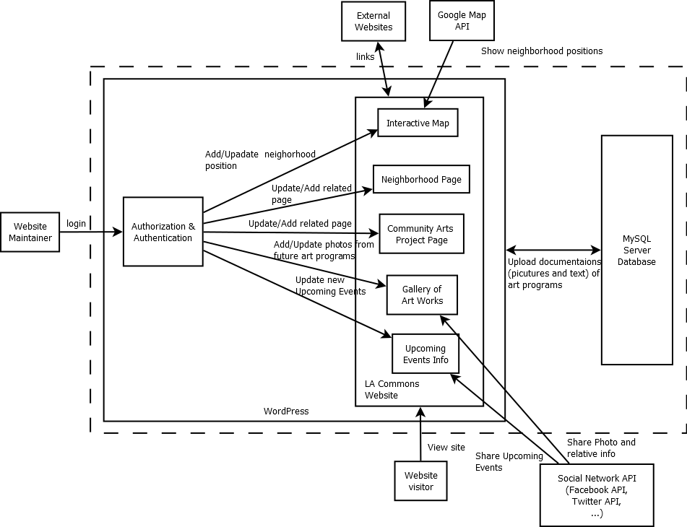
Figure 4: Element Relationship Diagram of upgraded LA Commons website

Business Workflows
Major difference: the new website will add Interactive Map, Community Arts Programming page, image gallery slide show and Social Network share button.
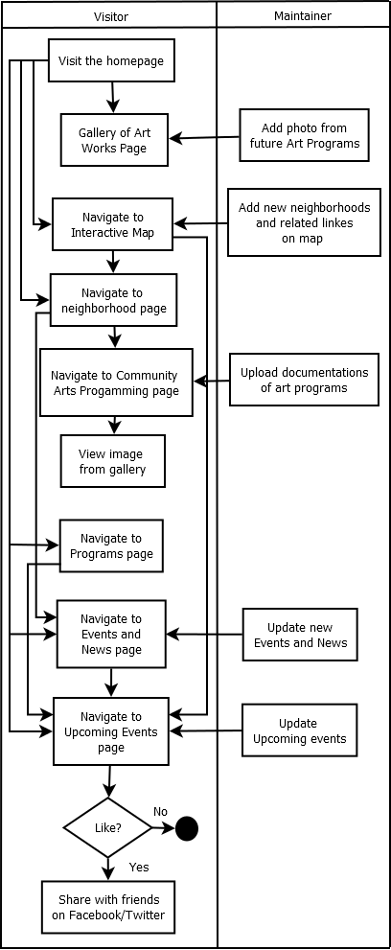
Figure 5: Business Workflow Diagram of LA Commons website

Organizational and Operational

Implications

Organizational Transformations

- The need to rent more space on Blue Host.
- The staff working at LA Commons need to learn how to use WordPress template feature to upload the documentations of their art programs.

Operational Transformations

- Having detailed documentations of the art works from the past art programs, funders can have a better understanding of what LA Commons do and whether their money is worth spending, and participates of these programs can see their works on the website.
- With the Interactive Map, neighborhoods people can find the art programs near them more easily and potentially more people will participate in these programs.

